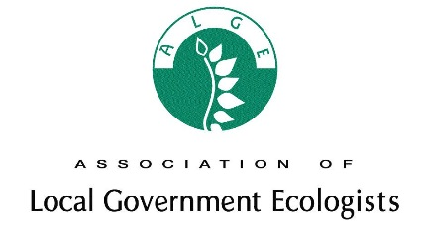
ALGE Conference & AGM
Tuesday 3rd December 2019

“Getting ready for biodiversity net gain”

Coin Street Neighbourhood Centre
108 Stamford Street, South Bank, London SE1 9NH

Registration Form

Please return the booking form by Tuesday 12th November 2019 to:

ALGE Conference 2019 c/o Iain Boulton, Lambeth Landscapes, Brockwell Hall, Brockwell Park, Brockwell Park Gardens, Herne Hill, London SE24 9BN. Tel: 0207 926 6209; Email: iboulton@lambeth.gov.uk

Prices
ALGE Member: £95
Non ALGE Member: £140
Concessions: £105

Number of Delegates
Number:

Name(s)

Authority/Organisation
Contact Email:
Postal Address:

Dietary Requirements (Numbers)  Please specify | Standard | Vegetarian | Vegan | Other (please specify)
Method of payment  Please tick as appropriate |  |  | PO Number

LATE BOOKINGS: Late bookings may be accepted in exceptional circumstances and will incur an admin fee; enquiries by phone call or email to iboulton@lambeth.gov.uk or 0207 926 6209
Information on the Conference venue can be found at: https://coinstreet.org/our-developments/coin-street-neighbourhood-centre/

