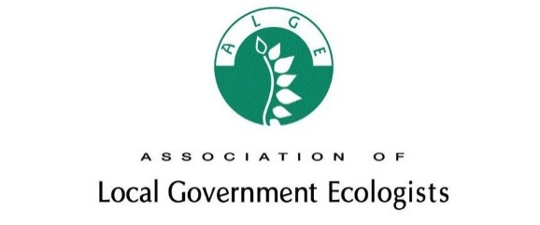

ASSOCIATION OF LOCAL GOVERNMENT ECOLOGISTS
SILVER ANNIVERSARY AWARDS

Nomination form

1. Category nominating for (please use one form per nomination and category)

- Local government biodiversity project award
- Local government changing the way we work award
- Regional champion
- Unsung local hero
- Collaborative working award

2. Region

- North East
- North West
- Yorkshire & Humber
- East
- Midlands
- London
- South East
- South West
- Scotland
- Wales
- Northern Ireland

3. Name and contact details of person nominating (please note we may need to contact you for further information on the nomination)

Name and job title
Organisation (if applicable)
Email address
Telephone number

4. Name and contact details of person/organisation being nominated (if organisation is being nominated, please included a relevant point of contact)

Name and job title
Organisation (if applicable)
Email address
Telephone number

5. Reason for nomination – please state how the nominee has met the requirements of the award and any specific outcomes of the work (maximum 500 words)

(Expand box as required)

6. Evidence – please feel free to submit any evidence you feel may support the nomination (website, materials etc); please note anything submitted in support in the box below

(Expand box as required)

